**HR DASHBOARD MOCKUP**

**TIMELINE SLICER**

Active Employees By Region

Termination Reason

**REGION SLICER**

**ETHNIC GROUP SLICER**

**FULL-TIME/PART-TIME SLICER**

Important KPIS

Active Employees by Ethnic Group

Average Tenure Months

Total Active Employees

Separations and Bad Hires

**DASHBOARD REPORT**

**Business Challenge**

We are to create a dashboard for he HR Department in the organization.

**Solution Delivered**

A dashboard was created to track the following KPIs.

1. Gender Diversity among different Regions.
2. Active employees per month.
3. Age Diversity.
4. Full-time vs Contractor ratio.
5. Active employees in regions.
6. Active employees by ethnic group.
7. Employee tenure over the years.

**Business Insights**

1. Its key to note that the East Region, is the only region that has more females compared to males. The other regions seem to have both genders of almost equal amounts except North and South Region.
2. The North and the South regions have notably more males than females.
3. There are fewer

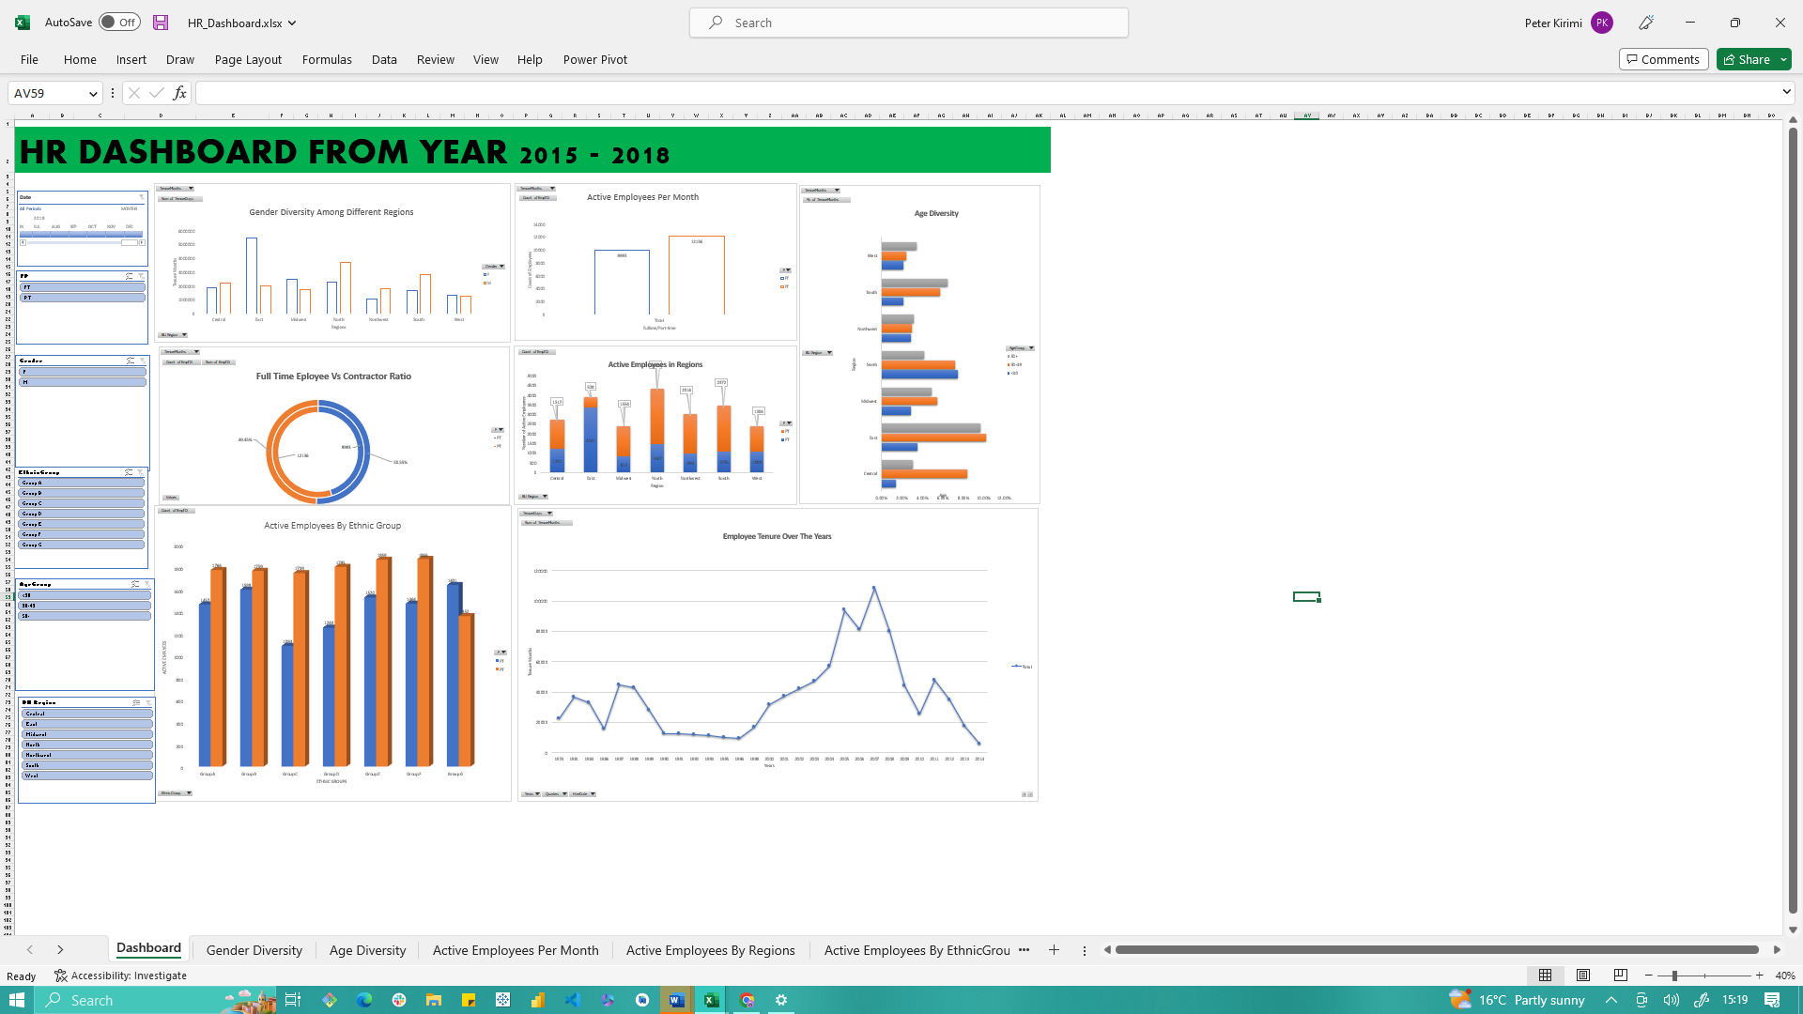

1. Full-time(active=9,993) employees compared to Part-time employees’(12,136) per month.
2. We have 49.5% Part time employees while 50.5% are full-time.
3. The East Region has notably more active employees than other regions. While the Midwest has the least.
4. Northwest region is more age diverse.
5. There are a fairly equal number of active employees in all ethnic groups.
6. Employee tenure increases over the years, we witness a decline starting from 2007-2010, followed by a slight increase in 2010-2011,then a decline towards 2012-2014.

**.**